***ABSTRACT***

Build Logistic regression model with R and SAS

Bonny

*Predictive modeling employs the method of using historical information on a certain attribute or event to identify patterns which will assist in predicting a future value of the same with a certain probability attached to it[1]. Its application is invaluable for of industry, business, and other fields. This paper will show the reader how to build a logistic regression model using R and SAS.*

*This paper presents the steps involved in developing Logistic Regression models based on Lobster survival during tethering experiments by carapace length. However, this model cannot stand alone and only applies to the geographical location where the study was carried out. Other factors, such as weather, strength of tethering tool and operators’ skill level will also affect the result.*

*In the meanwhile, I will compare the models built by R studio and SAS system.*

# INTRODUTION

# R is a language and environment for statistical computing and graphics [2]. In the other hand, SAS is the short form of "Statistical Analysis System", is a software suite developed by [SAS Institute](https://en.wikipedia.org/wiki/SAS_Institute) for advanced analytics, [multivariate analyses](https://en.wikipedia.org/wiki/Multivariate_analyses), [business intelligence](https://en.wikipedia.org/wiki/Business_intelligence), [data management](https://en.wikipedia.org/wiki/Data_management), and [predictive analytics](https://en.wikipedia.org/wiki/Predictive_analytics) [3]. R and SAS are both popular among analysis.

# Traditionally the Fishing industry has spent a lot of time and effort in programs to understand lobster fishery sustainability. The models presented here are to show the "Influence of Predator Identity on the Strength of Predator Avoidance Response in Lobsters" . The data can be used by fisheries to set minimum size limits for lobsters being caught. It can also be used in fishery replenishment projects to make sure that any farm-raised lobsters are released at a size which optimizes chances of survival, thereby guaranteeing the safety of the lobster fishing industry.

# prediction will save a large amount of labor and other cost.

# Theory foundation

In this section, I will provide a brief background of logistic regression. In [statistics](https://en.wikipedia.org/wiki/Statistics), logistic regression, or logit regression, or logit model is a [regression](https://en.wikipedia.org/wiki/Regression_analysis) model where the [dependent variable (DV)](https://en.wikipedia.org/wiki/Dependent_and_independent_variables) is [categorical](https://en.wikipedia.org/wiki/Categorical_variable) [4].That means the dependent variable can take only two values, "0" and "1", which represent outcomes as dead/survive.

As we know, the ordinary least squares regression can be only used as assumptions of normality of the responses. If we use ordinary linear model, the prediction of probability of survive will be ranged from - ∞ to +∞ , which violate the theoretical meaning of probability, ranging from 0 to 1. Hence, the dependent variable will apply a nonlinear transformation, log odds (Logit); the function of the DV and IV will be showed in the following manner :

**Log (Pr/(1-Pr))= β 0+ β 1* Length**

From the function above, we can get the following advantages;

1) The Logits we estimated can be to lie anywhere between -∞ to +∞. And this model is suitable to the responses (survive probabilities) are non-normal.  
2) This model with a linear form can directly related the parameter to logit of Survive.

We can transform the estimated Logit equation to the corresponding probabilities of survive to the following form:

**Pr=1/(1+exp^(- β 0- β 1* Length))**

To estimate the β parameters of the logistic response function, we can take the method of maximum likelihood estimation[5]. But, it is hard to get a closed-form solution manually, normally we estimate the parameter with computer-intensive numerical search procedure.

# Data Set

The source of this data set is E.B. Wilkinson, J.H. Grabowski, G.D. Sherwood, P.O. Yund (2015)[6].

"Influence of Predator Identity on the Strength of Predator Avoidance

Response in Lobsters," Journal of Experimental Biology and Ecology,

Vol. 465, pp. 107-112.

In table 1, “Length” is the carapace length in mm, “Survive” is the binary DV, 0 =No, 1=Yes. Data at individual lobster level (grouped in 3 mm length increments). There are total 159 counts. The model is about lobster survival during tethering experiment by carapace length.

*TABLE 1*

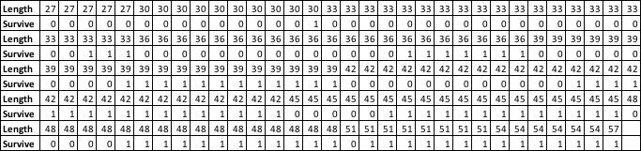

# Sample run

## Model in R studio

## First I will show you how to build the model in R studio.

## The graph below shows the probability of lobster survival versus carapace length, with the logistic regression curve fitted to the data.



In the logistic regression model, I run formula below with R to get the output table.

*glm(formula = Survive ~ Length, family = binomial("logit")).*

TABLE 2: summary of the logistic model in R



## According to Table 2,we can see that carapace length is significantly associated with the probability of survival. Since the probability of intercept is 0 is 1.19e-08,and probability of slopes of Length is 9.77e-09,both are much smaller than 0.02. p=0.0167( [Wald test](https://en.wikipedia.org/wiki/Wald_test)[7]).

## The coefficients for ‘Intercept’=-789597, and slope for ‘Length’=0.19586’ are applied to the logistic regression equation to estimate the probability of survival.

## As we mentioned above, the mathematic formula behind this model is

## Probability of survival =1/1+exp (-β 0- β 1*a).

## Here: a is the value in Length, β0 is the value of intercept, and β1 is the value of slope of Length.

## Now we names z1 as the probability of survive, to find the value of z1, we have formula below:

## z1=1/(1+exp(7.8959697- 0.1958579*Length))

## According to the model above, we can estimate the probability in TABLE 3.

## TABLE 3: Probability of survive

|  |  |  |  |  |  |  |  |  |  |  |  |
| --- | --- | --- | --- | --- | --- | --- | --- | --- | --- | --- | --- |
| *Length* | *27* | *30* | *33* | *36* | *39* | *42* | *45* | *48* | *51* | *54* | *57* |
| *Probablity* | *0.07* | *0.12* | *0.19* | *0.3* | *0.44* | *0.58* | *0.71* | *0.82* | *0.89* | *0.94* | *0.96* |

## To get the binary result, we take all Probability>=0.5 as 1, all probability<0.5 as 0. Then we obtain the binary value in TABLE 4.

## TABLE 4: Binary output of the probability for survive

|  |  |  |  |  |  |  |  |  |  |  |  |
| --- | --- | --- | --- | --- | --- | --- | --- | --- | --- | --- | --- |
| *Length* | *27* | *30* | *33* | *36* | *39* | *42* | *45* | *48* | *51* | *54* | *57* |
| *Probablity* | *0* | *0* | *0* | *0* | *0* | *1* | *1* | *1* | *1* | *1* | *1* |

## When the lobster’s carapace measures over 42 mm, the probability of survival is high. Now, let us test the accuracy of the model.

## We can get the whole output of probability for all values of ‘Length’, and command ‘cbind’ combines the values of ‘Survive’ and ‘yh1’ as a matrix to compare the accuracy. You can see the partial matrix below.



## Finally, we run ‘d=abs(Survive-yh1)’, ’d I’s a vector to list the difference between ‘Survive’ and ‘yh1’, with formula ’(159-sum(d)/159’, we get the accuracy of this model, 0.7106918. That means this model is not bad.

## With this model, the fishing industry can adjust their restocking size limit to only lobsters with carapace over 42mm, this should guarantee a higher probability of survival of lobsters released.

## B. Model in SAS system

## We can also build a model with SAS system, now I will show how to build a model step by step.

## Step 1, import the data, my data is an excel sheet. It can be imported in SAS system. Select ‘File’->’Open’--> ‘data’, then pick the file you need as picture 1-3 below.

*Picture 1*

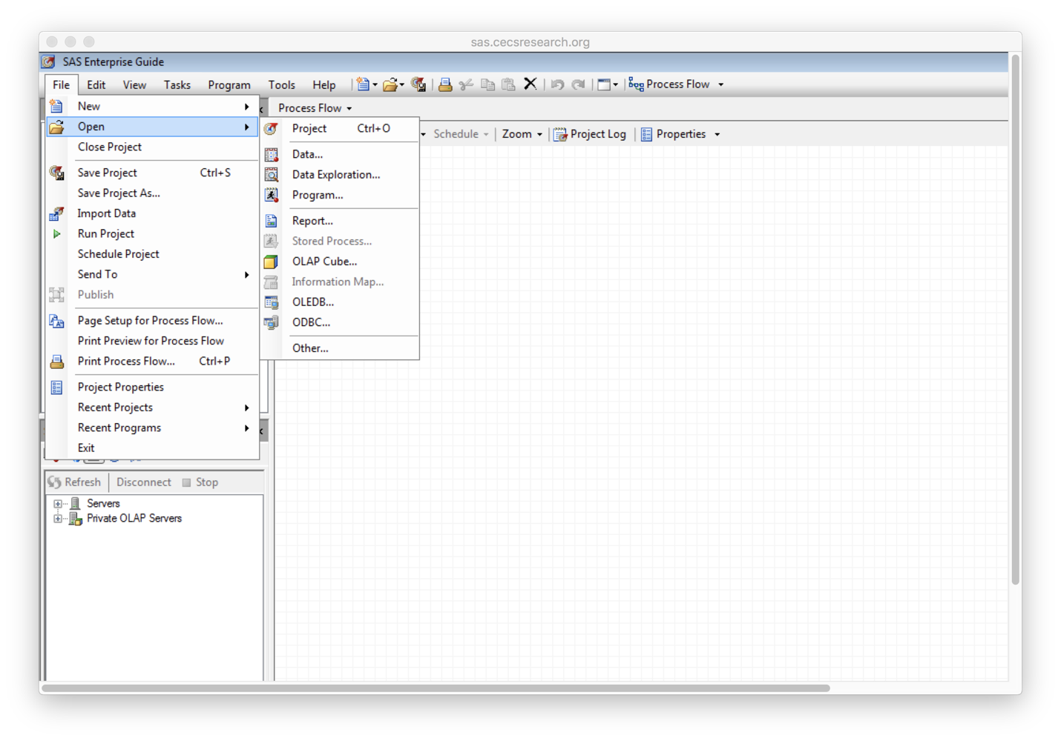

*Picture 2*

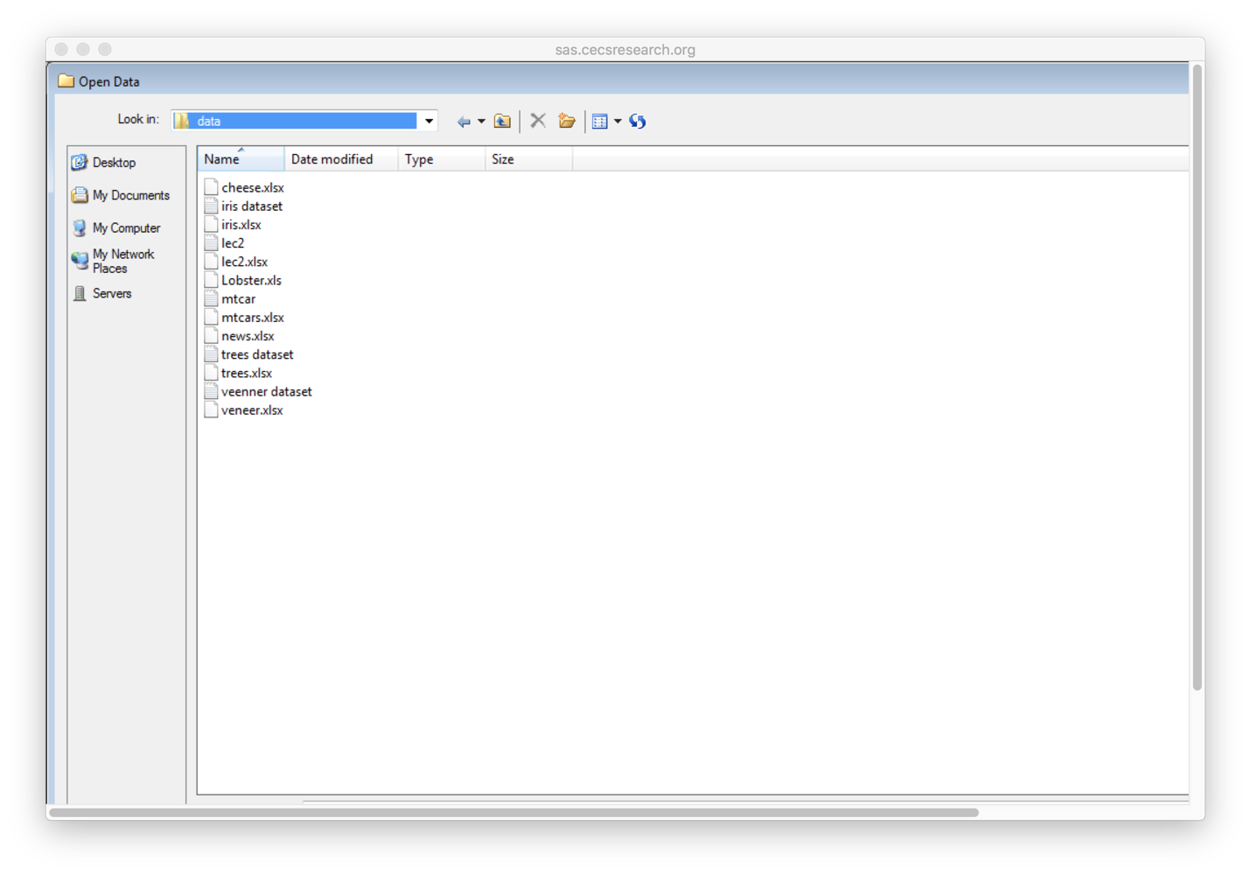

*Picture 3*

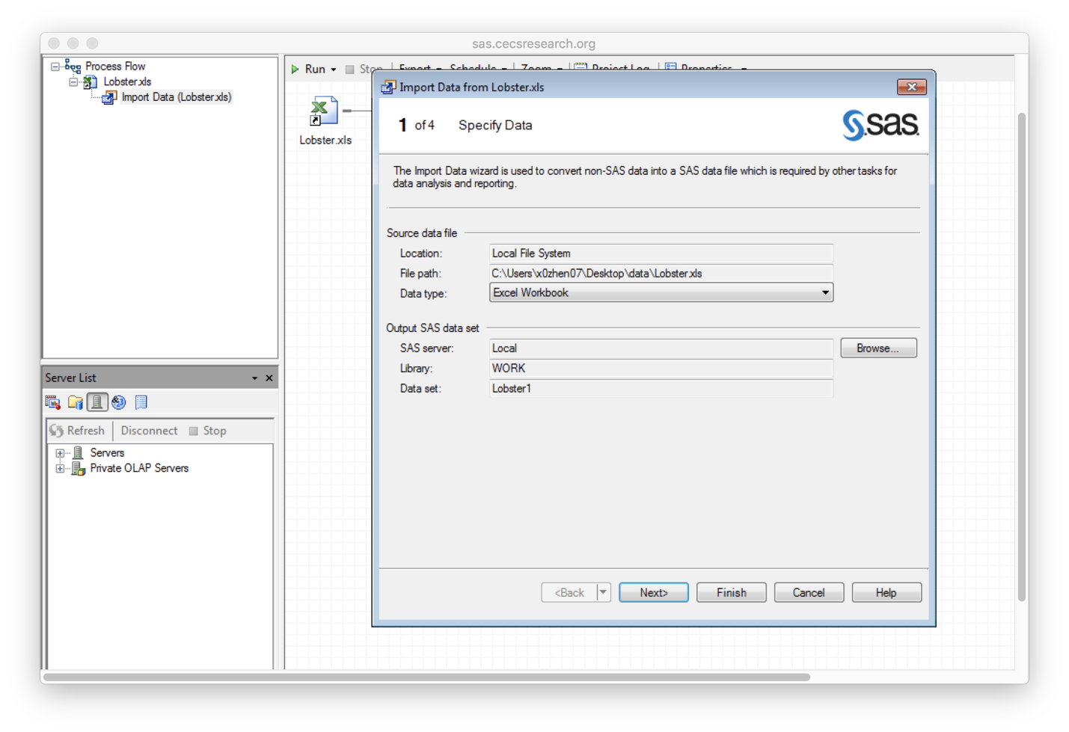

Keep taping button ‘next’ till page 4 of 4

*Picture 4*

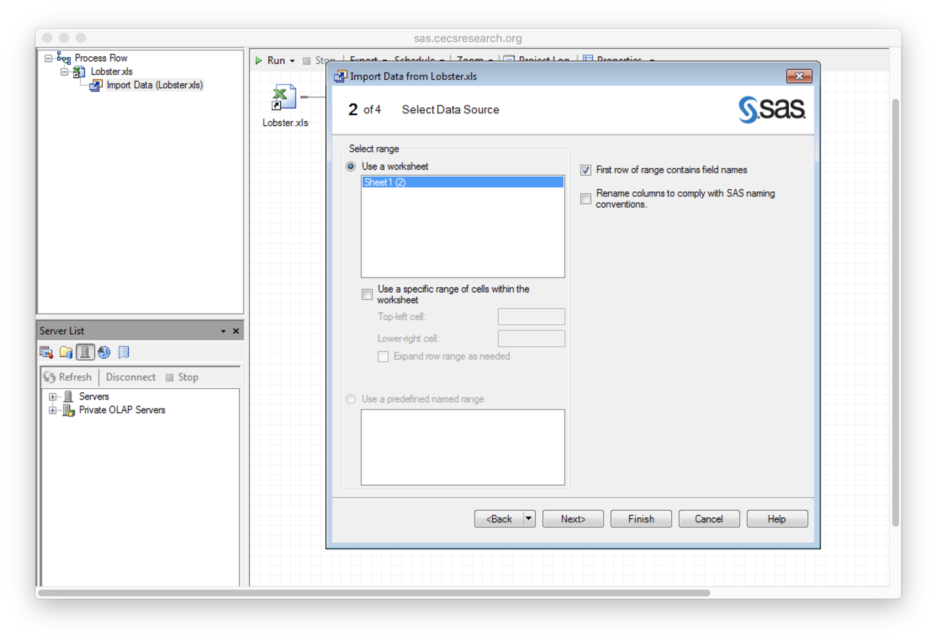

*Picture 5*

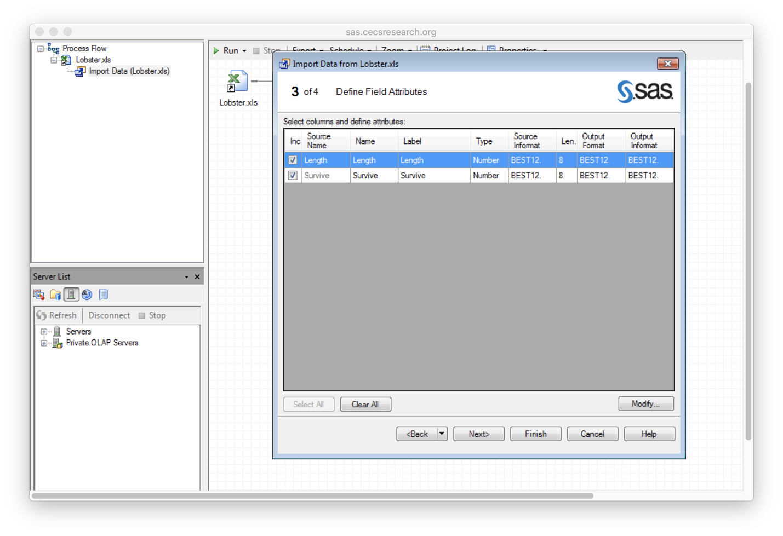

## Then select button ‘Finish’.

*Picture 6*

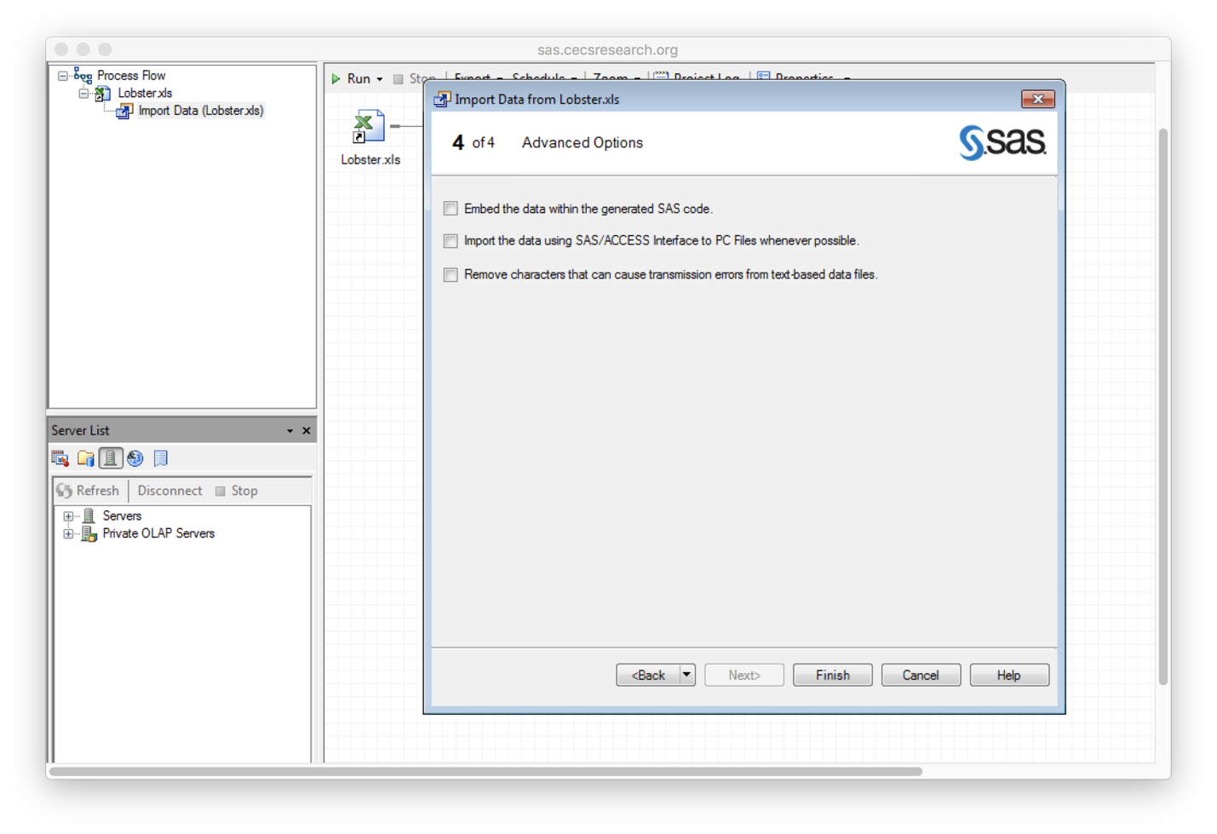

## When you tap finish, you will see the uploaded file as picture 7.

*Picture 7*

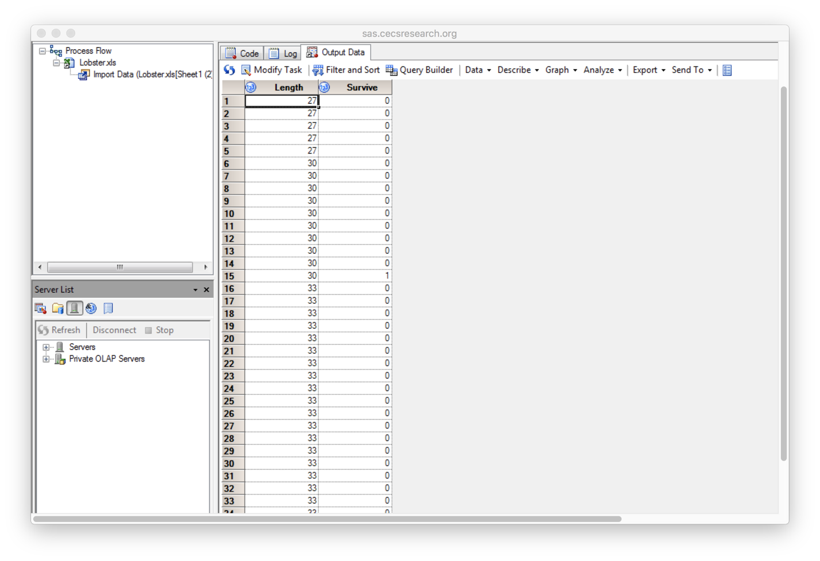

## Step 2, run the model

## First, pick the “Data imported” in work flow panel, and then choose “Task”-->”Regression”-->”Logistic Regression”

*Picture 8*

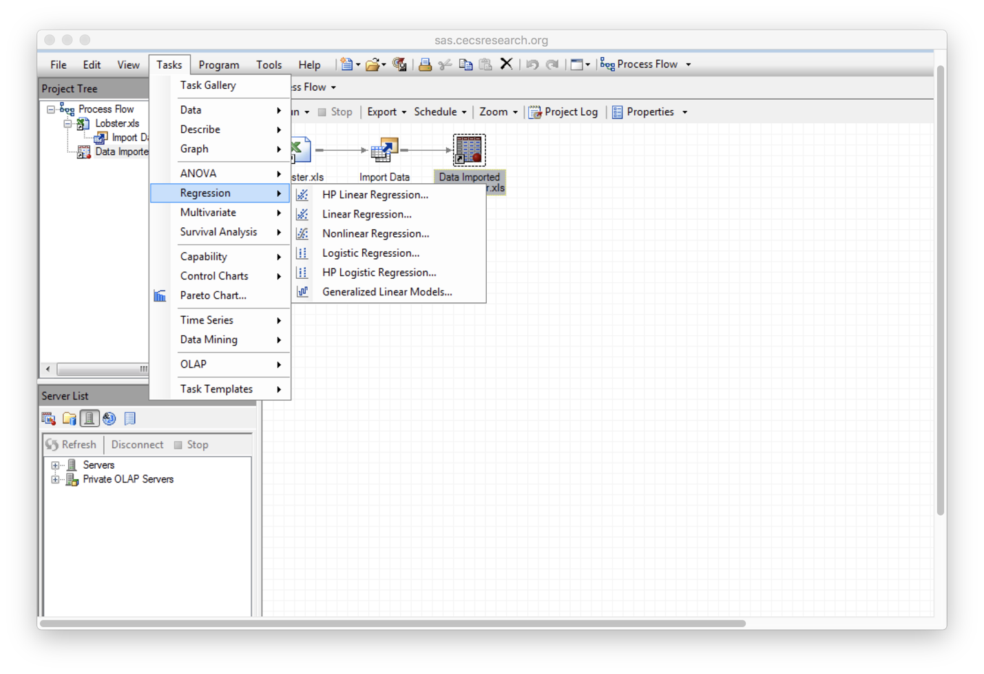

## Second, we will choose data, “Survive” is the binary depended variable, and “Length” is the independent or quantitative variable.

*Picture 9*

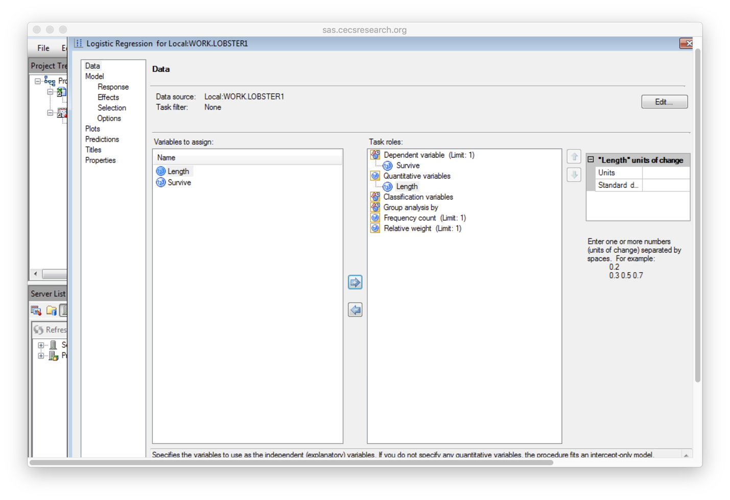

## Third, we set up Model-Response, “Type of model” is Logit, and “Fit Level to model” is “1”, since we need the model of “Survive” as 1.

*Picture 10*

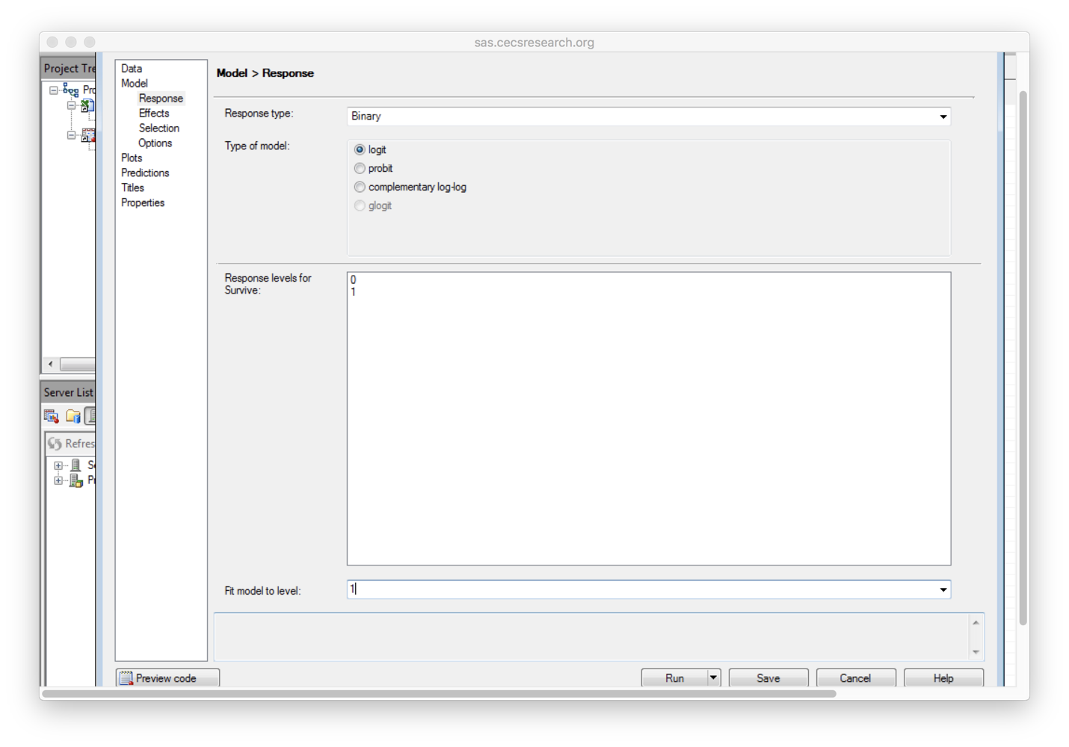

## Fourth, to choose “Effect”, here we pick “main” as “Length”.

*Picture 11*

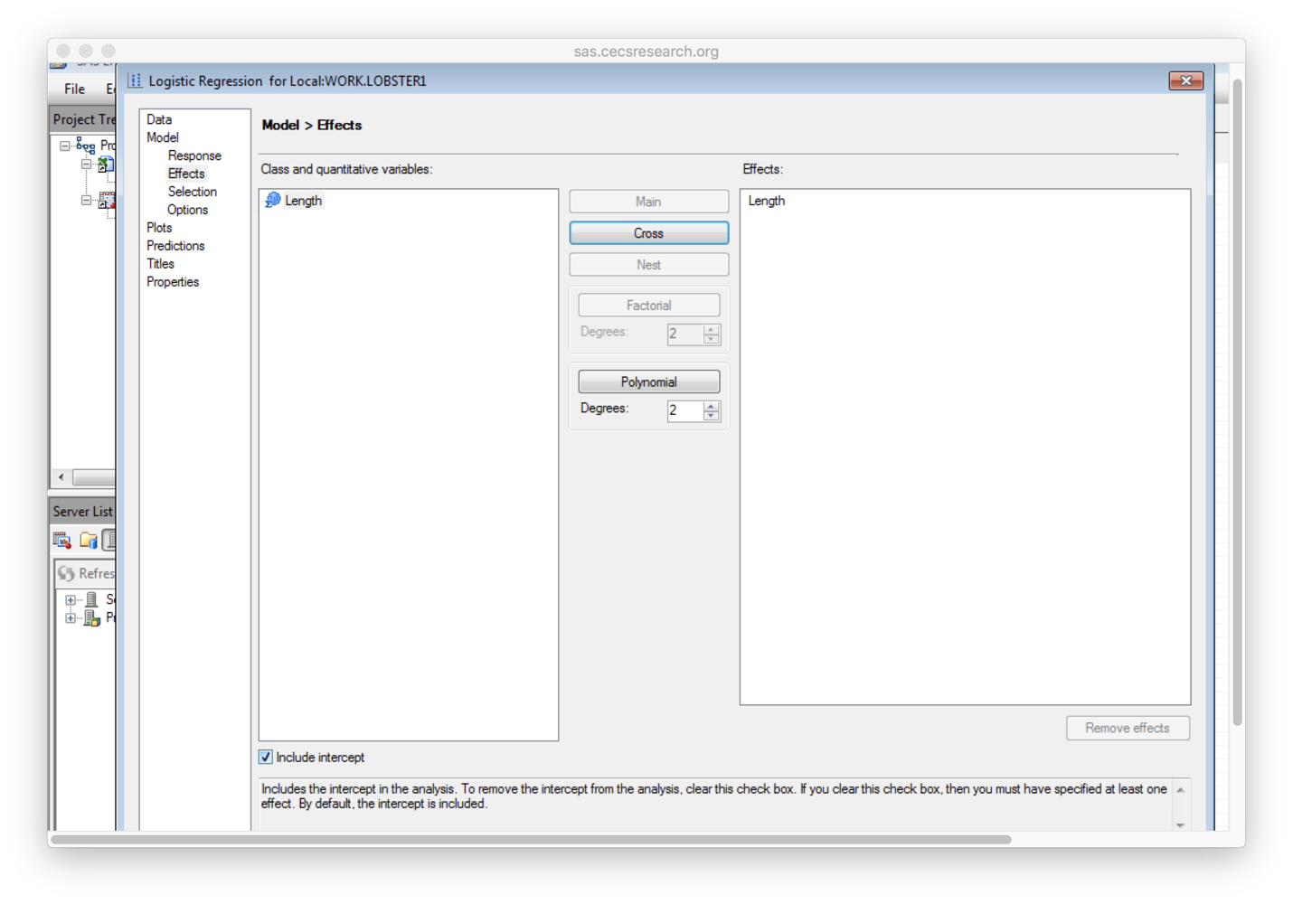

## In the end, we run the model. Table 5 gives us the intercept and slops of “Length” the same as what we get from R.

*Table 5*



We also get a graph of “predicted probabilities for “Survive=1” , which is the same as the graph from R.

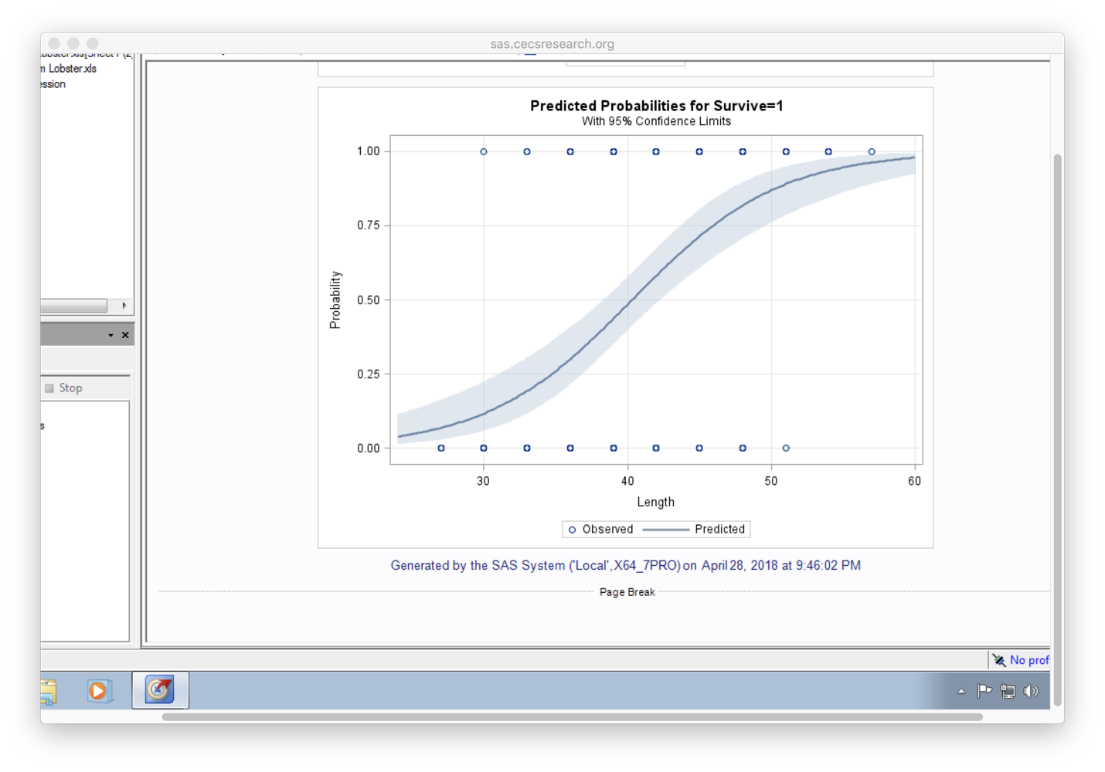

# Conclusion:

Now, let us compare the two models.

About the result, both systems run well with the same results and accuracy, since same “intercept” and “slope of Length” were computed.

SAS is easier to master and run, especially for beginners.

The SAS output is more Visual, once you build the whole model, the output shows up in one go.

R is not as intuitive and is more complicated, it requires the user to use the correct formula and commands to obtain the output.

R can be used to generate customized models so long as you use the correct formulas and commands.

Infrequent users of R may find it difficult to use compared to SAS.

References

1. Vijayalakshmi Sampath, Andrew Flagel, Carolina Figueroa.( Paper SD-016). “ A LOGISTIC REGRESSION MODEL TO PREDICT FRESHMEN ENROLLMENTS” . [Online]. Available:<https://analytics.ncsu.edu/sesug/2009/SD016.Sampath.pdf>
2. “What is R?” . [online].Available: <https://www.r-project.org/about.html>
3. “ SAS(software)”. [Online]. Available: <https://en.wikipedia.org/wiki/SAS_(software)>
4. “Logistic Regression”,[Online]. Available: <https://en.wikipedia.org/wiki/Logistic_regression>
5. Nuts and Bolts, “An Introduction to Logistic Regression”, [online]. Available: <http://www.appstate.edu/~whiteheadjc/service/logit/intro.htm>
6. Miscellaneous Datasets”, title “Lobster Survival by Size in Tethering Experiments (Individual Level data)”. [online]. Available : http://users.stat.ufl.edu/~winner/data/lobster_survive.dat
7. “Wald test”, [online]. Availabe: <https://en.wikipedia.org/wiki/Wald_test>